FIXED DEPOSIT CERTIFICATE Certificate No :No Issue Date : FD_Start_Date
This is to certify that Name has placed a fixed deposit amount of KES Amount to Fixed Deposit Account No: No at a rate of Rate% per annum for a duration of FixedDuration
The fixed deposit start date is FD_Start_Date, expected maturity date is MaturityD and the expected net interest upon maturity date will be KES. NetInterest
MaturityInstrPrefixMaturityInstrAmountMaturityInstrMiddleMaturityInstrAmount2MaturityInstrSuffix
Authorized Signature
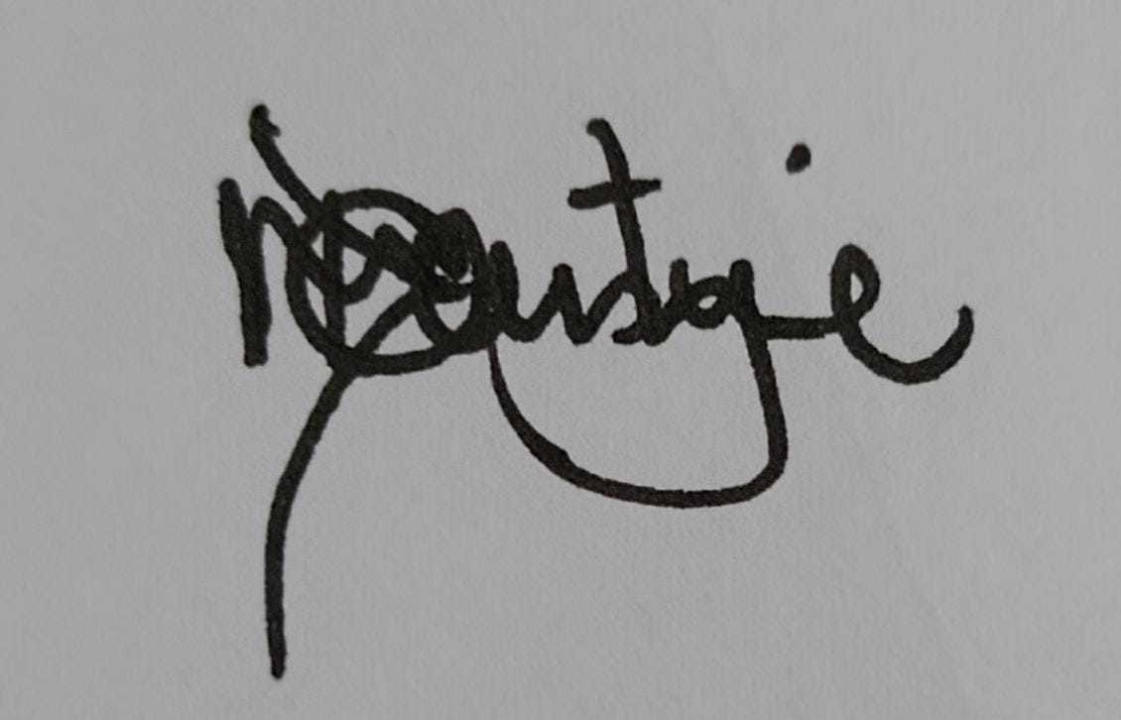
Early withdrawal will result in forfeiture of interest.

